**The Million Dollar Swing Setup**

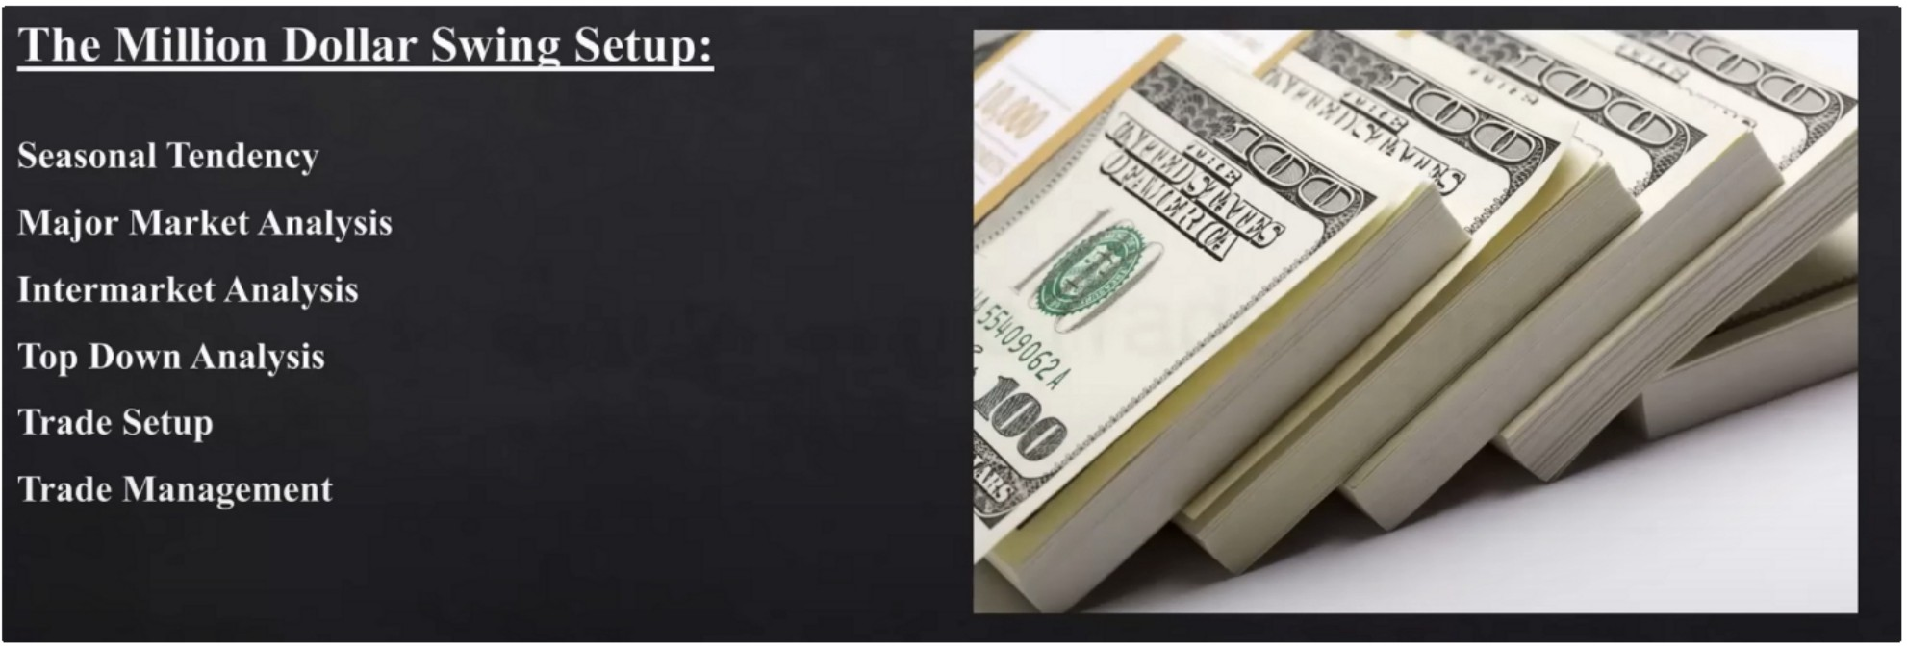

This is the best condition that repeats many times This teaching is the process

Is there a Seasonal Tendency to Buy presently or soon?

**SeasonalTendenc:**

If **[YES**I - then proceed to the Major Market Analysis Process If [NO I - then consider another asset or market that does.

* If not other asset or market offers a Seasonal Tendency - **Wait** for the next one.

If theres no seasonal tendency then we cant swing trade

**Ma·or Market Anal sis:**

Arc the Interest Rate markets & or Currency Markets [USDX] Trending?

If **[YESI** - then proceed to the Commodity & Stock Filter Process

If **[NOi** then consider Short Term or Day Trades for now. **Wait** for Swing Trading conditions.

Arc the Commodity & or Stock Market Trending'?

If **IYESI** - then proceed to the lntcrmarkct Analysis Process

Ir **[:\OI** then consider Short Term or Da, lrades for nm,. **\\ait** for S,, ing Trading conditions.

Both of these have to be in agreement

We only need 1 of each group to be trending Bullish idea

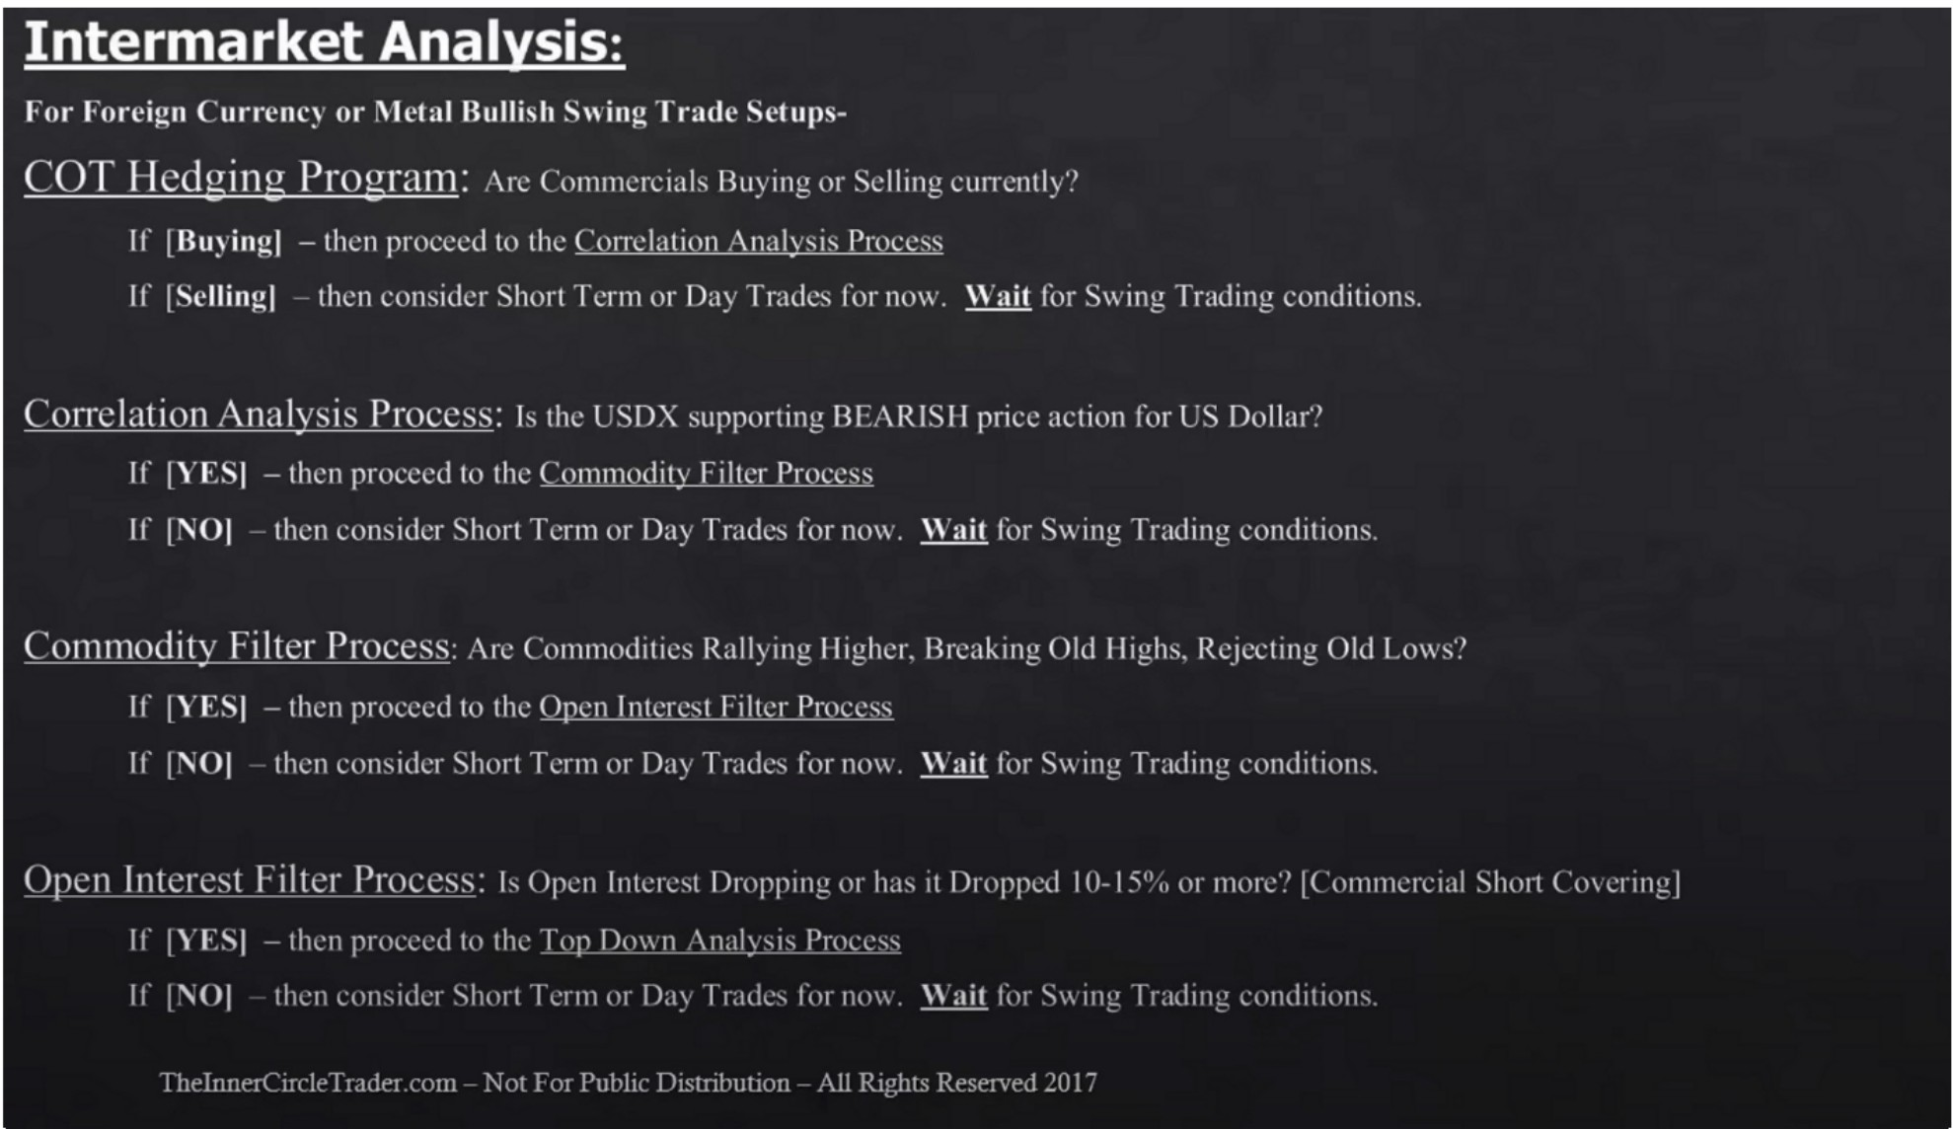

Bearish idea

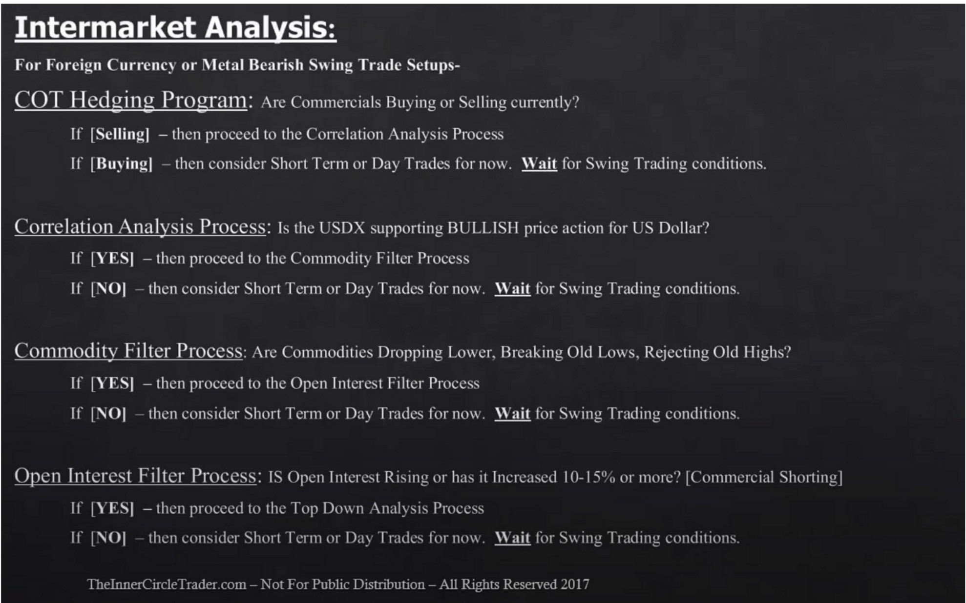

# To Down Anal sis Process:

I) t\otc thL' 9-1 X month histmy.

*2)* Identify all PD ,\rrays on Monthly. Weekly. Daily andhour timcframcs and Transpose all to ynur 4hour timcframc chart.

JI t\otc the !PD/\ Data Ranges nn the Daily cha11 that arc 20--40-(,() days back from today. Look for the PD arrays In assist in their i,kntiticatinn.

-l) trait tk IPDA Data Range PD Arrays arc c,haustcJ or traJcJ tn ti,r the 20 Jay lookback 11101c nut tn the 40 Jay lonkhack tkn 60 Jay lonkhack.

:-i) Look for IPDA Data Rangcs and PD :\rray:-.to 1.:onn:rgc with one anoth..:r to dt:h:nninc I ligh Prohahility Institutional ()rdcr 1:low & kn.:ls.

6) Based on the Bullish or B..:arish stanrc or pn:misc you arc trading forus on thc rcspcrtin: PD ,\rrays for Trad.: si.:tups.

If Hulli"ih tl,uh 1111 \h1111hl: \\l·l·kl: lbil: 1>1-.l·11u111 \rT;i:, 1,i fra111c ;iI< J\J(i cntr: \Ill

It R1.':1ri,h 1;1'-·11-, 1111 \111111111: \\'-·d,I: lbil: Pr--·111111111 .\rra:, 1P fr.1111'-' :1 SH<)R I 1.:1111: 1111

Buy trade setup

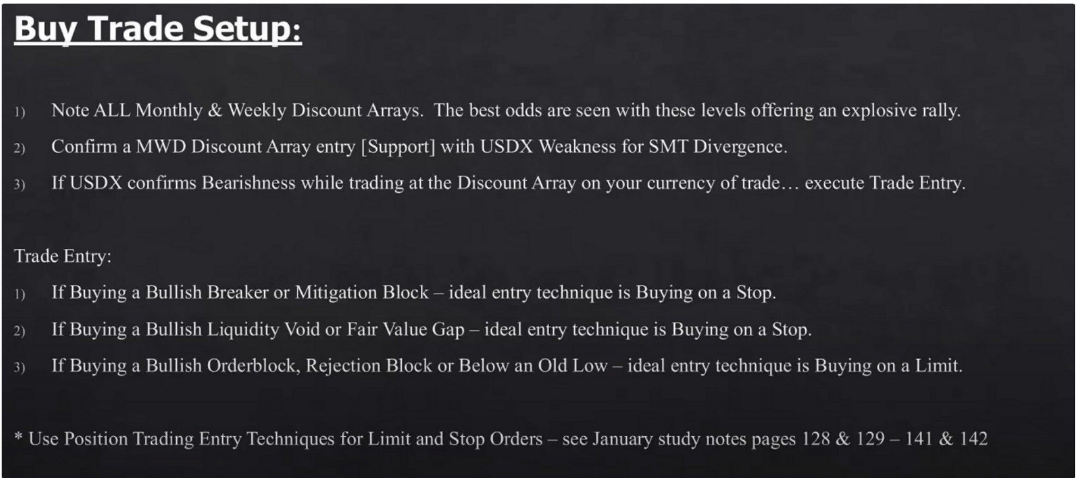

Sell trade setup

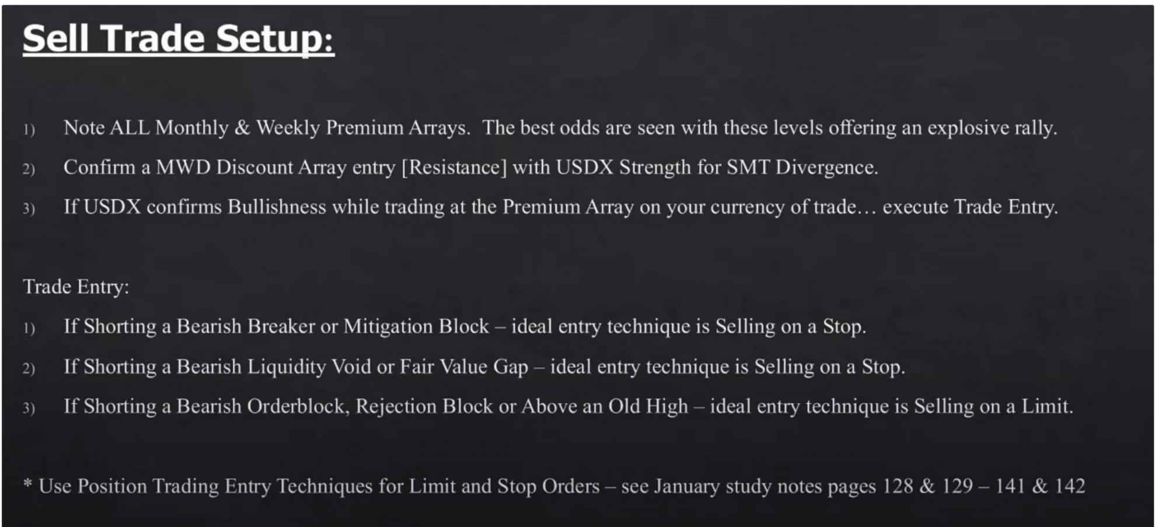

Buy trade management

# Bu Trade Mana ement:

Look for contrary f\:1\\-'I) Premium Arrays to reach for while long if applicable look for Fib c.\ll.'ll'.'-ion conllucncc:-. \\ ith J>n:mium Arrays. l.t.:an: Stop Loss from initial plact.:mcnt until Pril'l.' has 1110,·i:d I *>* of your intended trade din.x:tion.

If trad(' mo,·cs in your favor 1 of your inti:ndl.'d objl.'ctin: take somdhing off in profit. Use 0-.>0° o for scaling I '1 profit.

_,

\IO\c l'rotccti,c Stor l.oss to llrcakcvcn :\l·Tl'.R l '' rrolit is taken.

\\.hen trad..: mon:s to 50°0 of your inh.:nd..:d oh_j1,;<.:ti,·c look for new buying oppol1tmiti..:s to add hack th..: 14 tak1,;n off ath:r a shot1 term dcdin1..·. l'ak1..· Full position off at intl'IH.kd Pr1..·mium Array Ohjccti, L' or 75-X0° o and trail stop loss hclo,, the most l°l.'l'l.'111 4hour Short Term l.ow.

Ile mindltd the markc·t rnn & "ill l,kl'i, make a 11111 for Sell Stops al orjust ab,"c :iO"., of the range you hold thruugh. Don't nish Stop trailing. s, **lfStop1>cd out** - **reconsider th<· orii:inal reasons for the tra1k- if still rnlid** - **rccnkr at Ill'\\ \1\\1) Discount .\rm .**

Sell trade management

# Sell Trade Mana ement:

Look for c,>ntrary 'v!WD Disrnunt Arrays 1,, reach for \\·hilc short ifarrticablc look for Fih c,tcnsion contlucnccs with Discount Arrays. Lean: Stop Loss from initial placement until Price has mo,cd I J of your intended trade Jin.:-rtion.

If trade mo\Cs in your fo,or 11 of your intcrukd ohjcl'tin: take so1111:1hing off in prol'it. lJsc 20-J0°o for sl'aling ]'1 profit. tvlmc· Protccti,c Stop Loss to llrcakncn ,\FTFR l"' rrofit is taken.

\\"hl.'n trad1,.; mo,·cs to )0°o of your in11..·nLk·J oh_j\..·1..:ti\'C look for ncw shorting opportuniti..:s to add hal·k tht.: 1.1 tak1.:n off after a shol1 ti..·rm houJH.:1..·. Take 1-"ull position off at inh.:mkd Disrount :\rra:y OhjL·1..:ti,·L· or 7.'.'-X0° o and trail stop los'.'-t ahoYL' the most rcL:cnt -thour Short Tl'nn I ligh.

B,.: mindful the markc-t ran & ,,ill likdy makL· a run for Buy Stop:-. at or just h1,:lo\\ '.'0°,J ofth1...· rang.I..'. you hold through. Don·t ru:-.h Stop trailing.

,, **lfStnpp,·d nut** - **rl'considl'r till· nrii:inal rl'asnns for thl' trad,·** - **ifstill ,alid** - **n·,·nll'r at** Ill'\\ \)\\I) **l'rl'mium \rra .**

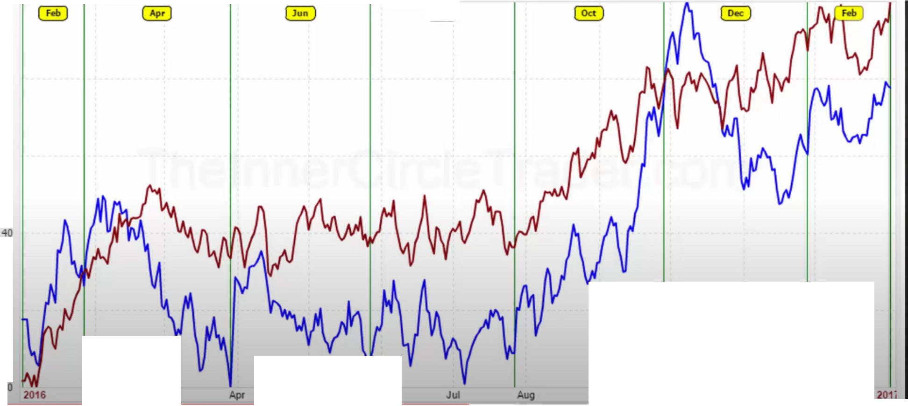

Gold{CtlX) 40 v.. , 5e•sonal(19n-2016)

100 Jan 0 2017: ■ Year. 77.55 ■ 15-Year. 100.00

80

60

20

Feb

Mar

May

Jun

Sep

Oct

Nov

Dec

ZBH17 • T-Bond • Dail

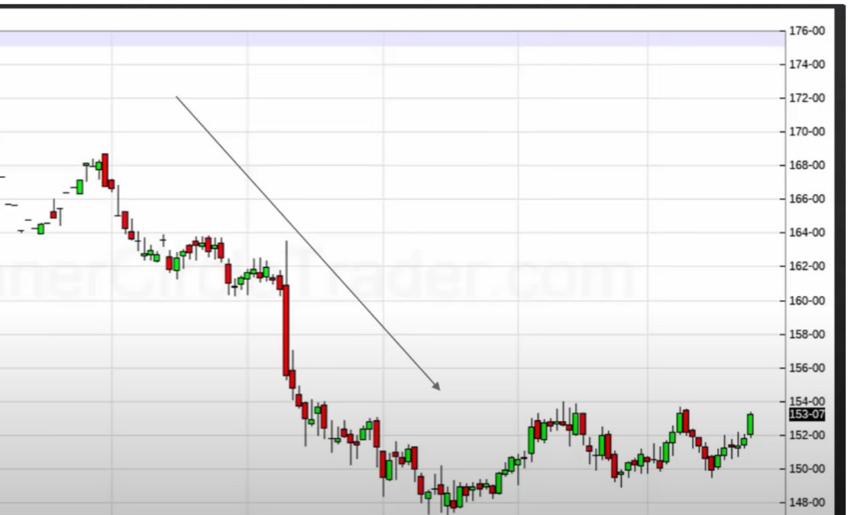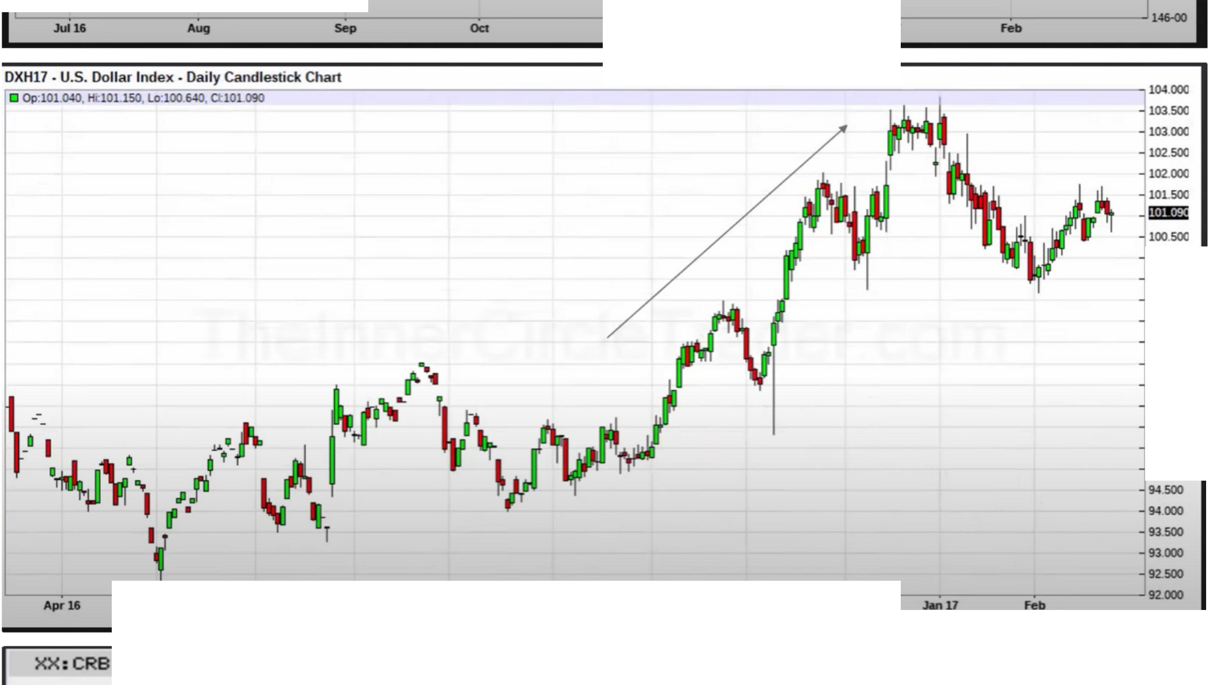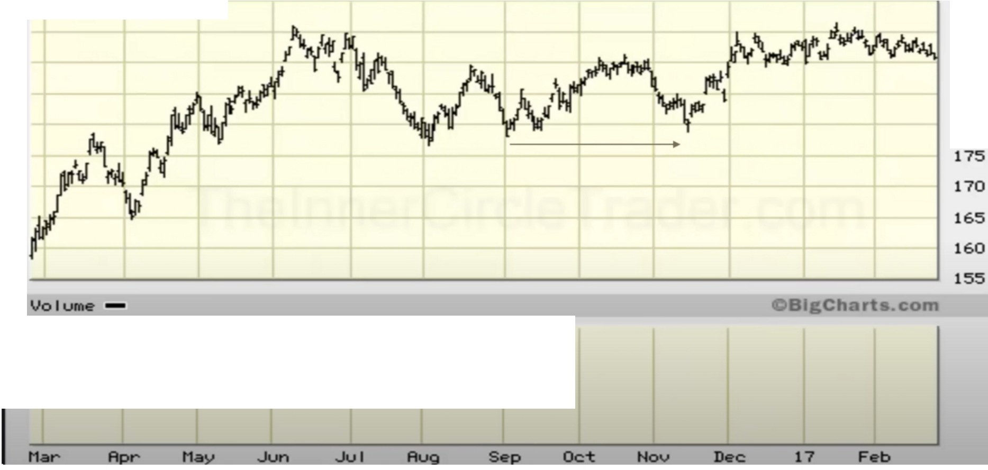

C Op:152-01,HdSl-12 *y* Candlestick Chart

- **'Lo:151·28, CtlSJ-07**

- --

- - 11

...,.

Jun Jul Aug Ocl - Dec

Dai I*y* :::-----========== -;..:.

**100.000**

99.500

99.000

98.500

98.000

97.500

97.000

96.500

96000

95.500

95000

2/24/17

200

195

190

185

180

Exncohavonlge provides

ume data.

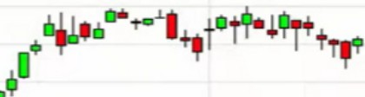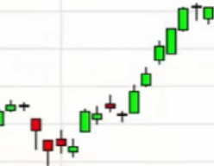

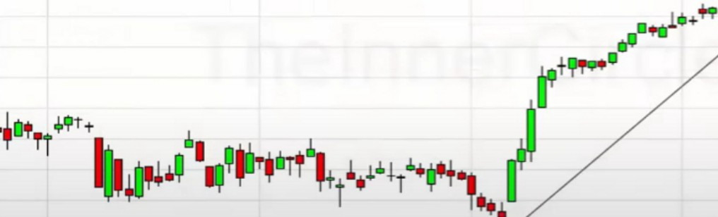He uses $DOWI for the stock market

SOOWI - DOW Industrials - Daily Candlestick Chart

--□ 0p _20=.=1s=L•=1. H<=20 .S2.L=.1•...2.0. .=ic-_=.. .cuo S2.L=1• ,2.1,ooo.oo

t

**Bl!llli!**

20,60000

20,400.00

20,200.00

20,000.00

19.800.00

19,60000

19,40000

19.200.00

19,000.00

18,80000

18,60000

c---

**..........1 ......................... m...,....... u.............11111111111111 1,11111111,11111111111111111111111111**

..-

18,40000

18.20000

18,00000

Sep l&

OC1

Nov

Dec

..Jan 17

Feb

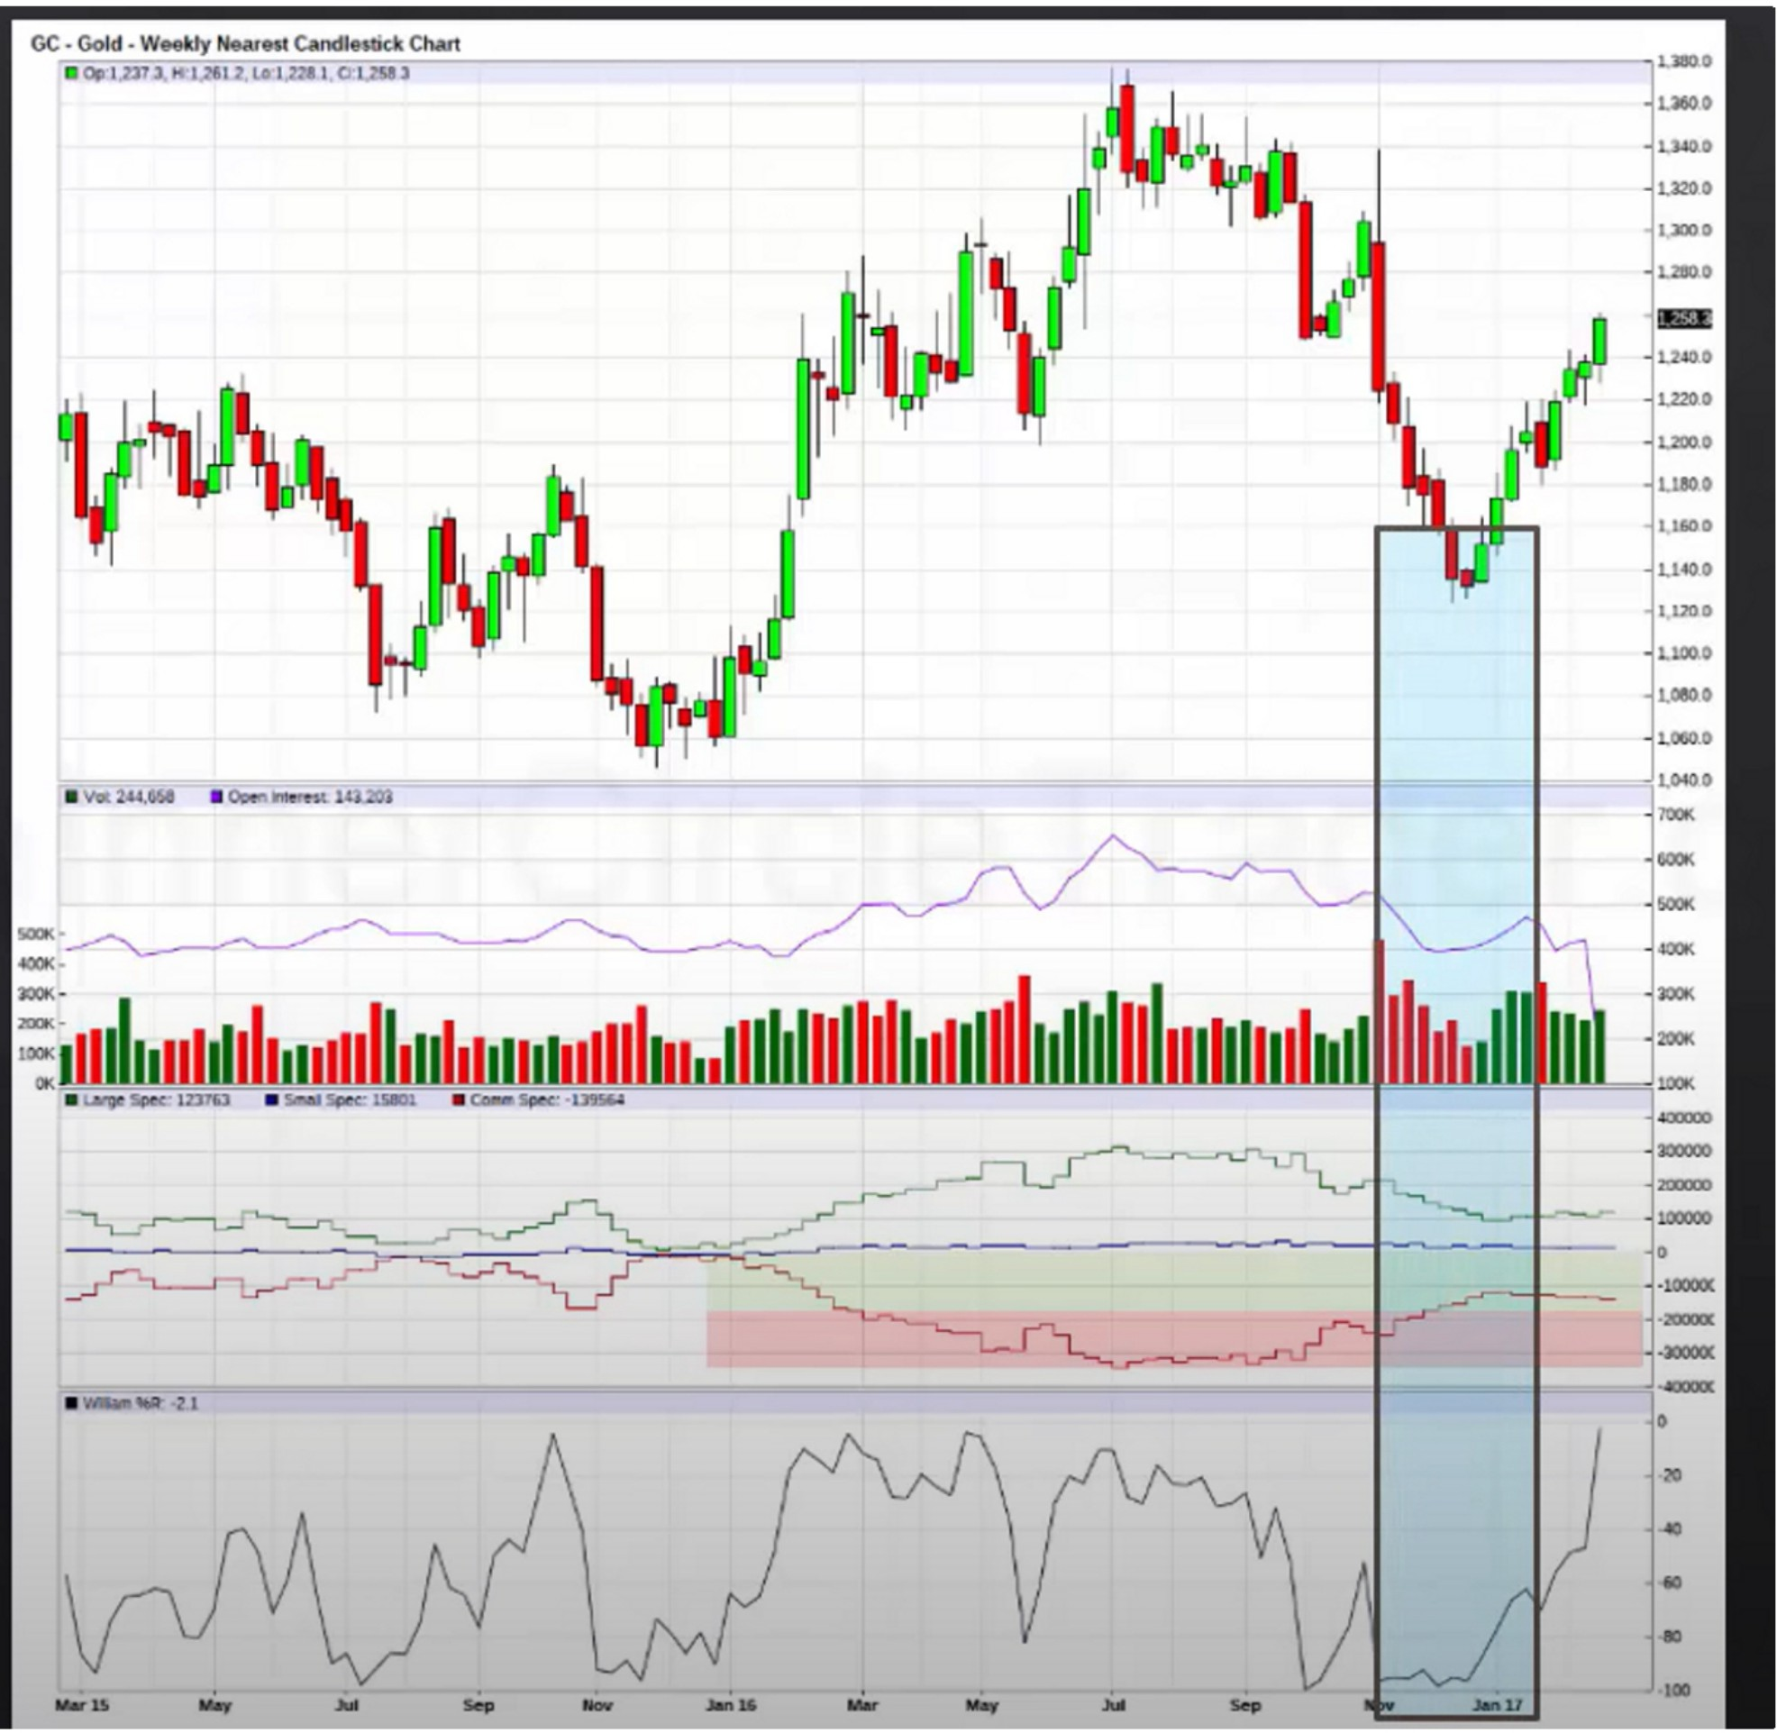

GCJ17 • Gold • Daily Candlestick Chart

IJOp-:l,250-.6,Hi:-l,261.2,-Lo:l,-2488-,Ctl-,2.583 l,J70.0

•.y · ... **+t·1** :::

=

\ I

t 1,300.0

1,290.0

1,280.0

! ..+

**lr1**

**,** , 1 it

§

**11**

**' 't**1. '11+ @l

¥ ' 1,170.0

1,1600

l,l.500

-

**----'tmtr.--;-t !1,1400**

l,lJO0

- 1,1200

**Sep 16 Oct Dec**

----,104.000

103.500

**103.000**

102-500

102-000

101.500

**mlm**

100.500

**100.000**

99.500

99.000

98.500

98.000

**97.500**

97.000

96.500

96.000

95.500

95000

94500

94000

93500

**93.000**

92.500

92.000

**Ap,16 Moy Jun M**

**Oct Mow- Dec Ml 17 Feb**

1'11

1080-0

**1070-0**

!I I

1061Hl

1061Hl

-

1040-0

1

1020-0

-

I+

1000-0

980-0

970-<l

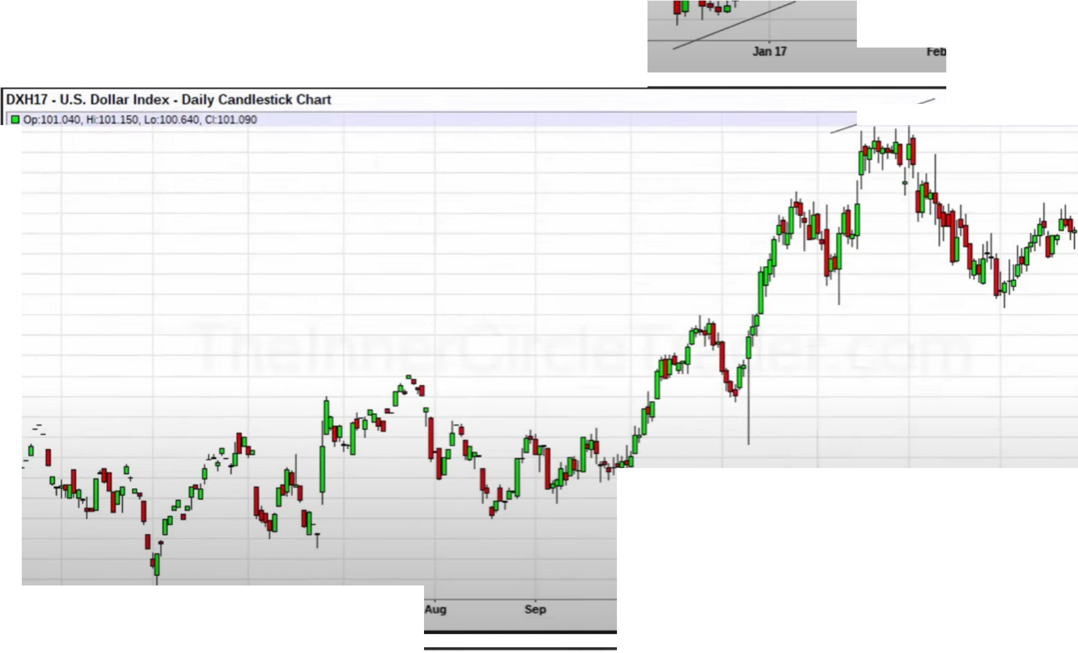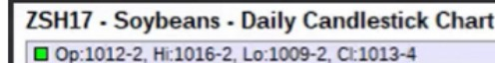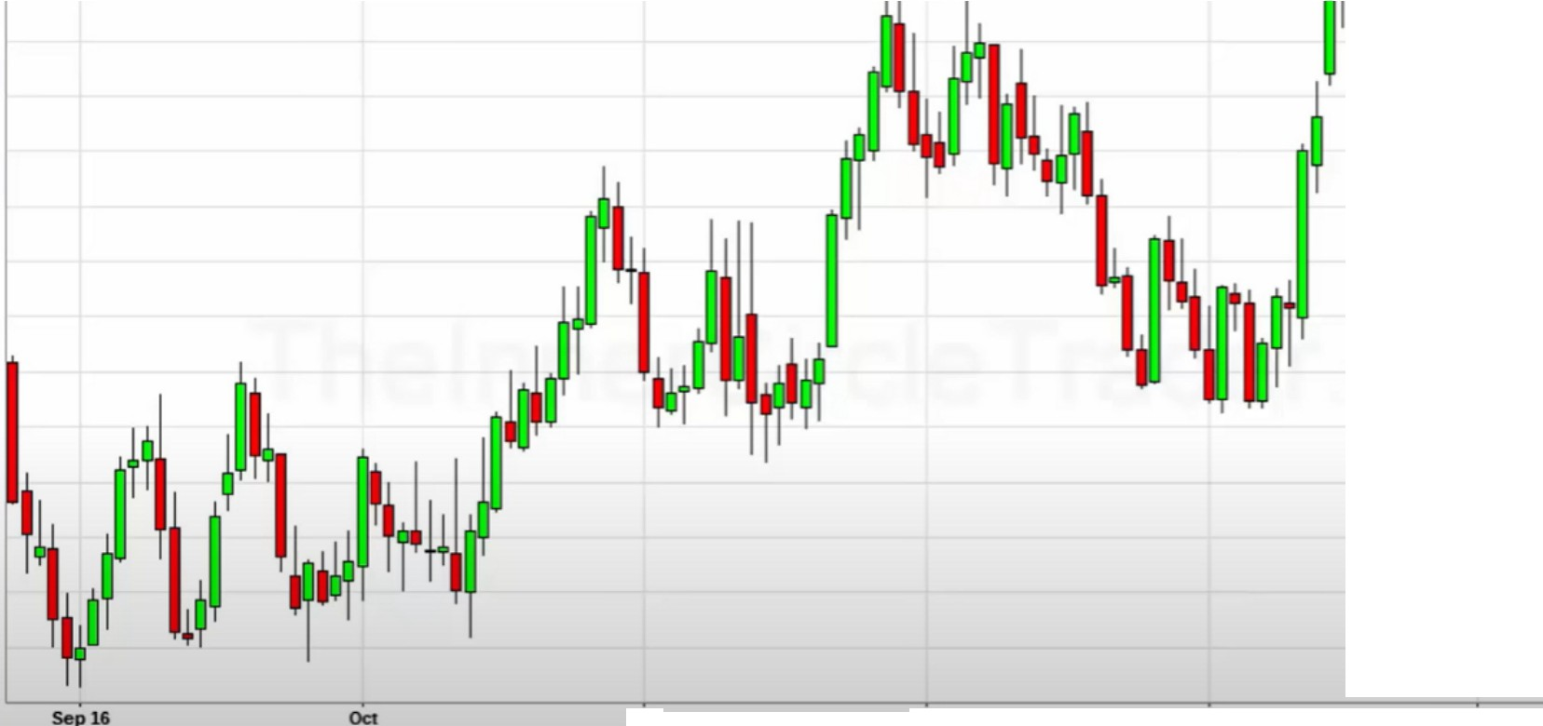

- Dec **Jon** 17

960-<l

950-<l

940-<l

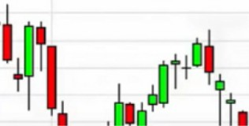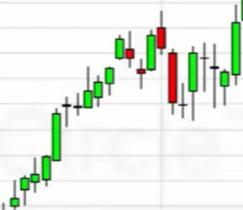

_

_

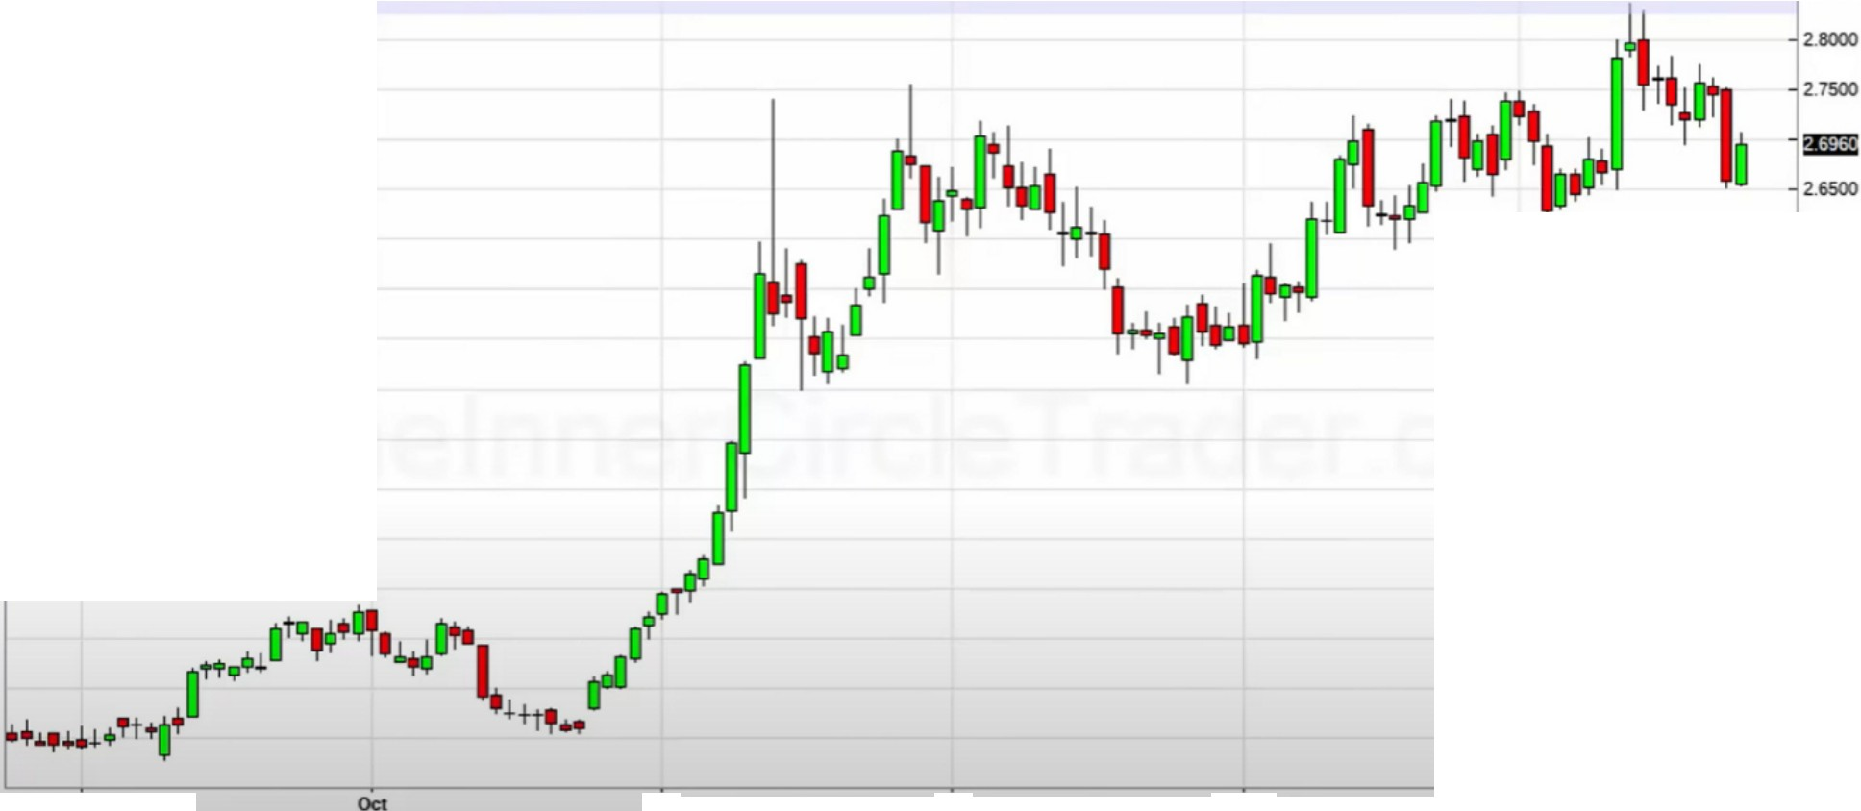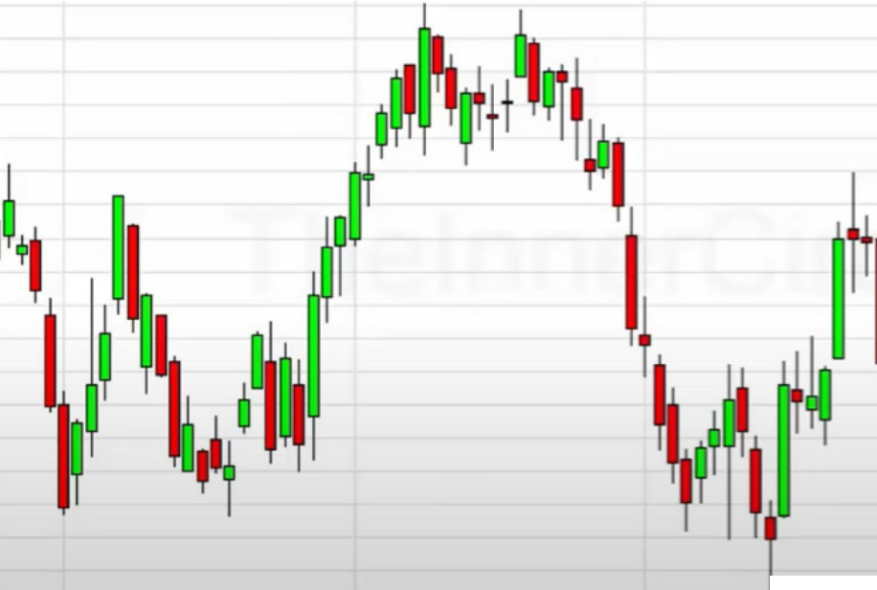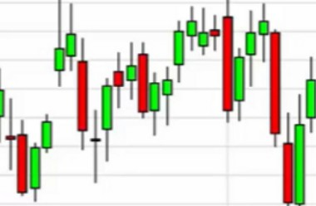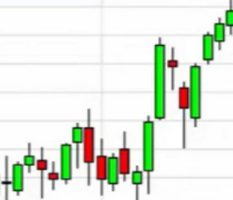

lijj'

#T I

52.00

SL50 SLOO 50.50

5000

**49.50**

**49.00**

48.50

48.00

4750

**47.00**

46.50

4600

4550

-

----

- ' 4500

**Sep 16**

Dec

-- 2.05()()

Feb

,u500

==---HGK1=7-Hig"-c=hGra=--c-deC==op r---=--cc.Oaic=-=-ly _ndlem_·ckCh_M

**fl Op:2.6550, 2.7065, Lo:2.6530, Cl:2..6960**

Dec

**2.1000**

Sep16

2.6000

2.5500

2.5000

2-4500

2.4000

2.3500

2.3000

2.2500

2.2000

2.1500

==---CLJ17 -Cru deOi IWTl -Dail=-=-ycan_dlesu_·ckC

**Jon** 17

Feb

**Jon** 17

-

,

==---l 17=•Live C =le-D ailyC =dle=stick ChM

* **Op·ll6.600, Hi:116.700, Lo 114 600, 0:.114 950**

,. ++\. =

t ' ·

==::

*l,*

:11:2.=

w.=

uo.=

109.=

106.=

107.=

**106.000**

105-

* Op:54.33, Hc54.Sl, Lo.53.76, 0.53.99

--

Oct

S7.00

56.50

5600

SS.50

When price goes to equilibrium is when you expect a stop run like in the example below before taking off, then we wont see another stop run until it gets to the last quarter

The range is made from the monthly OB to the first weekly PD array target

When you break the range down, from EQ to the start 1142, you can divide that range also and then you have your quadrants and can see the fractal price swings in the larger price swings. Do the same for the range above EQ, divide that also.

When we trade trough teh EQ on the upside, expect a sell stop run, then the second run is usually not going to see a stop run until we get to the last quarter or last third.

We can project that swing to get a more accurate idea into the weekly PD array Price shouldnt see another stop run intil we break that red high

So, theres going to be a stop run after midway is breached --+ Then it trades trough EQ again --+ Then it will retest and it will retest the EQ high, so the red high noted in the example above that caused the run on stops, and in that retrcament youre likely going to see a stop run, thats usually the last stop run. 1st swing grade, equilibrium, 3rd swing grade

Its fully rule based

All the seasonal tendencies that ICT likes in the january lesson, thats the only asset classes he uses for swing trading. ICT mostly does short term and day trades

Swing setups setup around 4-6 weeks

If there isnt one thing in the setup, then dont neglect the whole idea, just wait for more price action or wait when it does come